**TMS EEG Data – Stuttering (Resting State)**

**(EBNeuro Mizar)**

13 PWS

15 Fluent Speakers

4096 Hz sampling rate

31 electrodes (see Figures); ground electrode below Oz electrode, reference electrode on the nose

(average reference?)

Epochs: -200 ms (file BL) to + 500 ms (file TEP) locked to single pulse TMS delivered on SMA “complex” (see figure) (-10 to +20/35 ms “lost” for TMS artifact)

(TMS vs. Sham)

Data already cleaned, with accepted epochs (different numbers of epochs between BL and TEP conditions)

Filters: 0-200 Hz; TEPs data were averaged in every condition, also using linear detrend for remaining TMS artifacts.

*Bands (0.5 Hz steps?)*

Delta (1-4 Hz)

Theta (4.5-7.5 Hz)

Alpha1 (8-10 Hz)

Alpha2 (10.5-12 Hz)

Beta1 (12.5-16 Hz)

Beta2 (16.5-21 Hz)

Beta3 (21.5-30 Hz)

Gamma1 (30.5-70 Hz?)

Gamma2 (70.5-150 Hz?)

Data of interest:

-Scalp Distribution?

-Neural Sources (Distributed and ROIs?)

-Partial Direct Coherence? (connectivity)

-Correlations (Neurophysiological, Behavioral)

-Differenze in picco “alpha”?

*Figures: EEG cap*

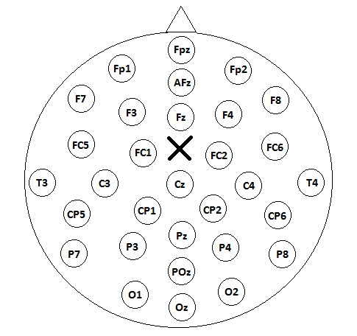

EEG montage (cross indicates TMS delivery on the SMA).

*Networks of interest* (ROIs; BA -bilaterali- per PDC e Neural Sources; in parentesi, n. ROI):

DMN : (1)10,11; (2)40,39; (3)23,26,29,30,31 ; (4)22,21,38.

SCN : (1) 6 (SMA/pre-SMA); (2) 10; (3) 32,33,24,12,25,34.

SN : (1)13; (2) 32,33,24,12,25,34.

ECN : (1) 40,39,7; (2) 46,45,47,44.

DAN : (1) 7; (2) 8.

VAN: (1) 39,40; (2) 44,45,46,47,9.

CBCT/SMN: (1) 1,2,3,5, 40; (2) 4; (3) 6; (4) 13,44,45,46,47; (5) 21,22,41,42,43.

Speech-Motor Network (from TMS /EEG TEPs Data): (1) 6 (SMA/preSMA); (2) 6 (dorsal/ventral premotor); (3) 13, 44,45,46,47; (4) 39,40,7; (5) 20,21,22,41,42,43.

Data-driven?